Task 2 – Demonstration of Replication of data on S3 Bucket across different regions.

i. Creation of source and destination buckets with AWS S3.

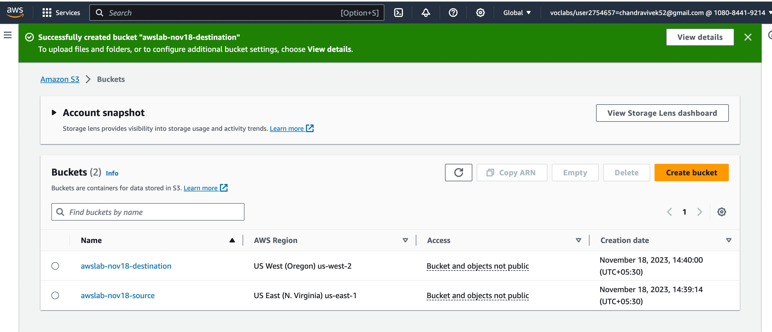

ii. Creation of a text file named as ‘before_replication.txt’ prior to replication.

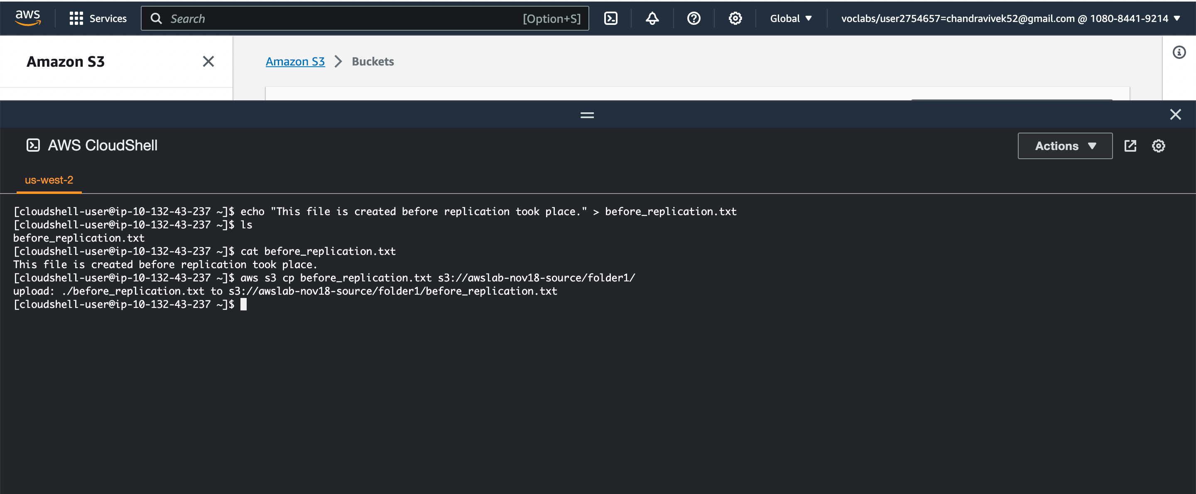

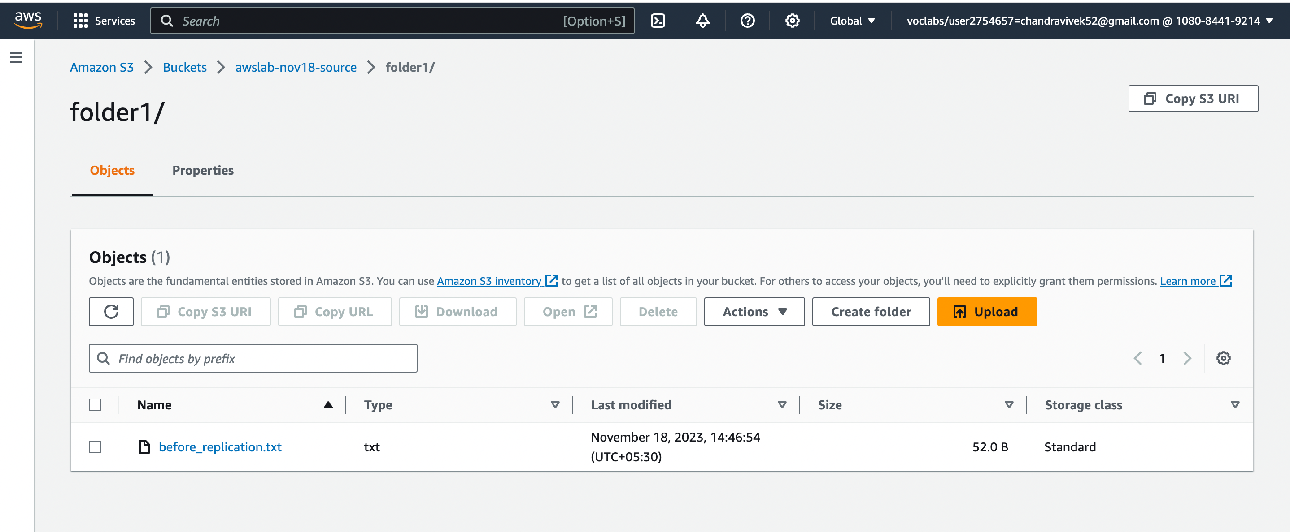

iii. Setting-up the replication rule.

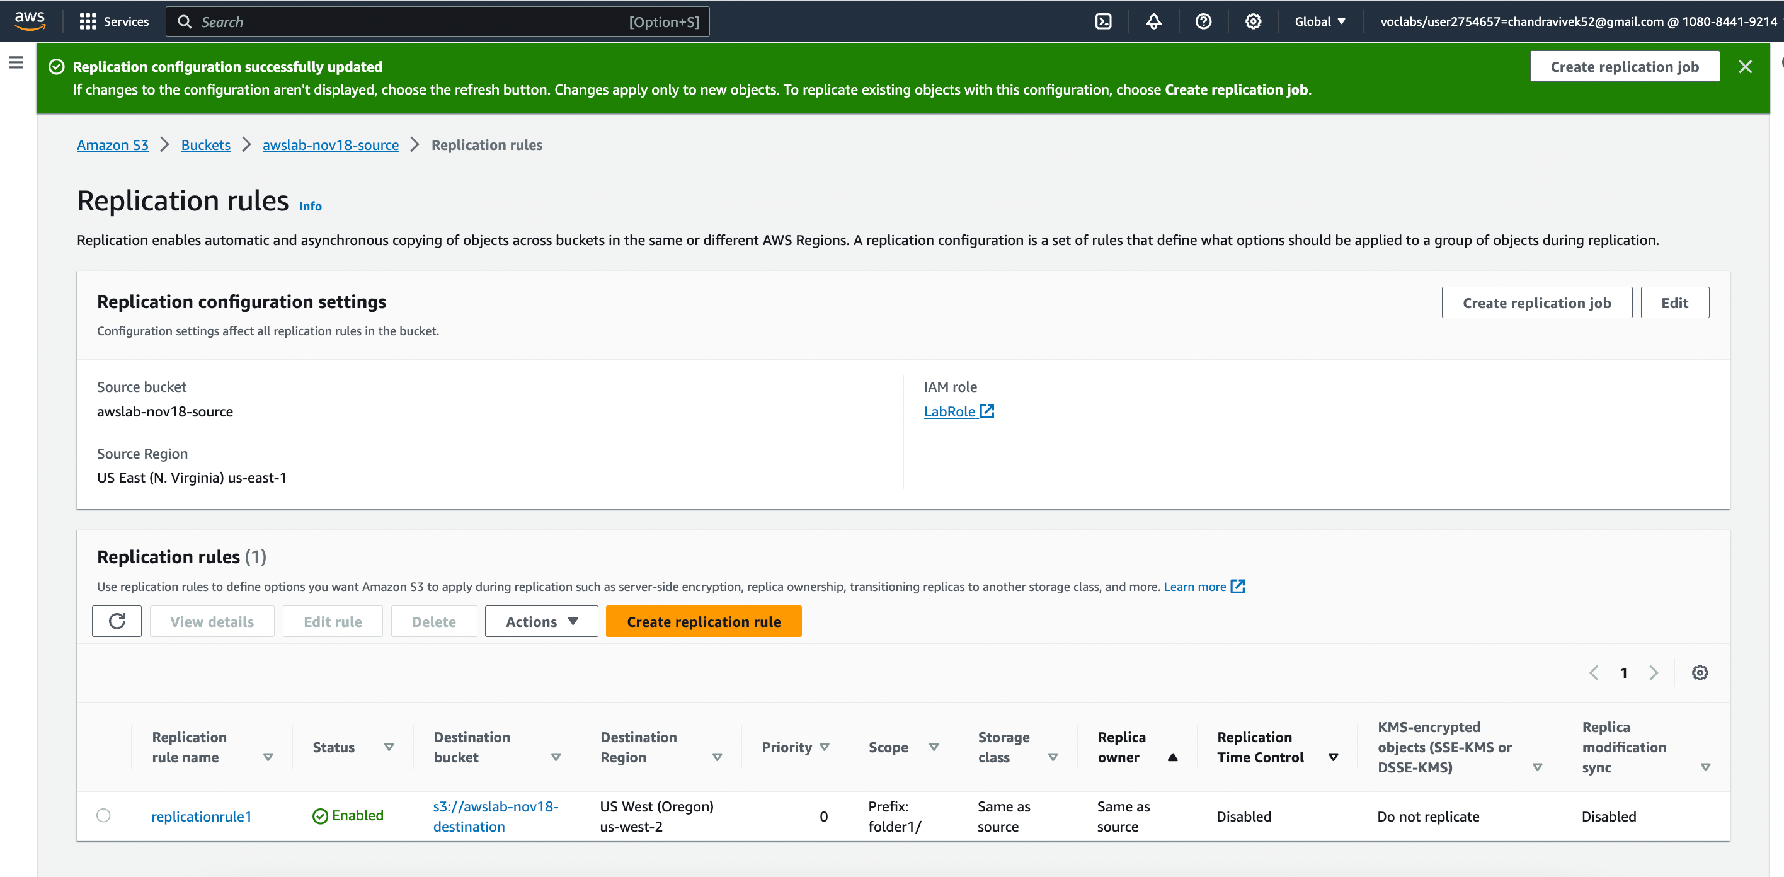

i

v. After Replication – Phase I

Creation of file ‘after_replication.txt’ after the enabling versioning and replication.

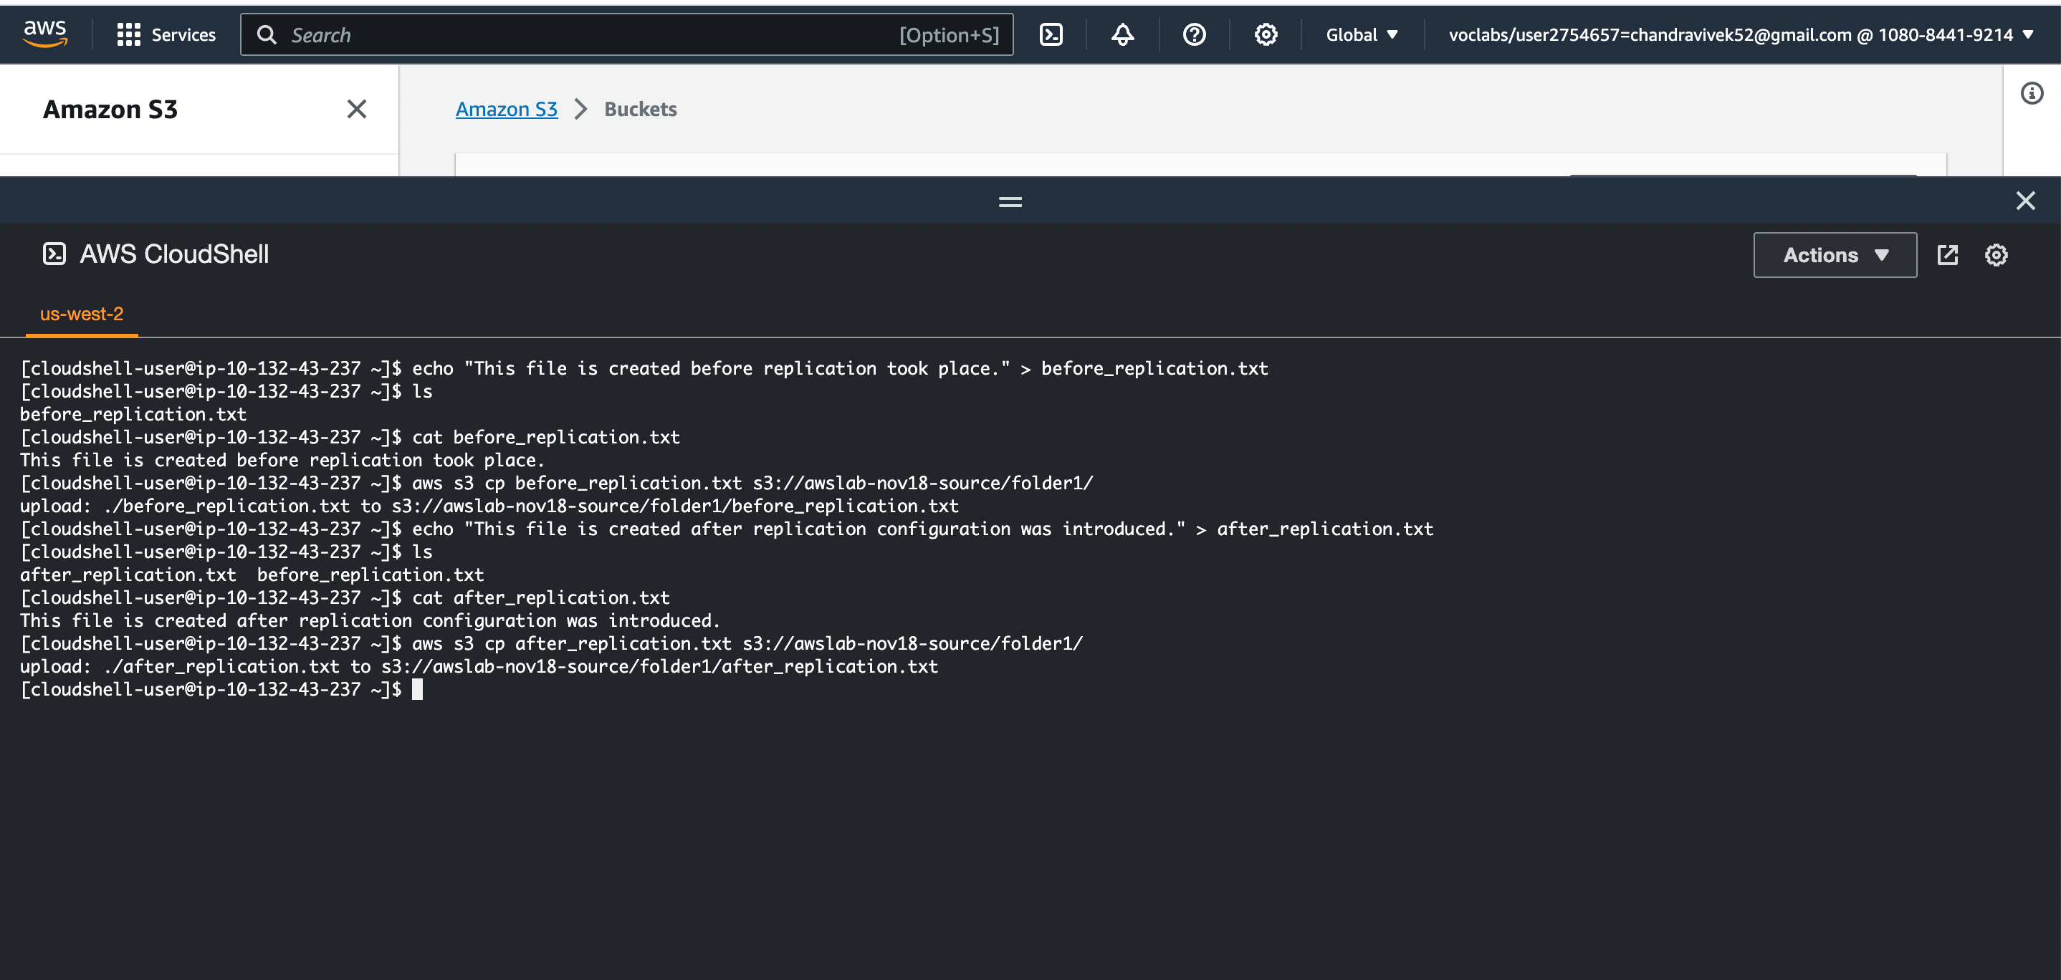

File replicated to the prefix ‘folder1/’ in the destination bucket.

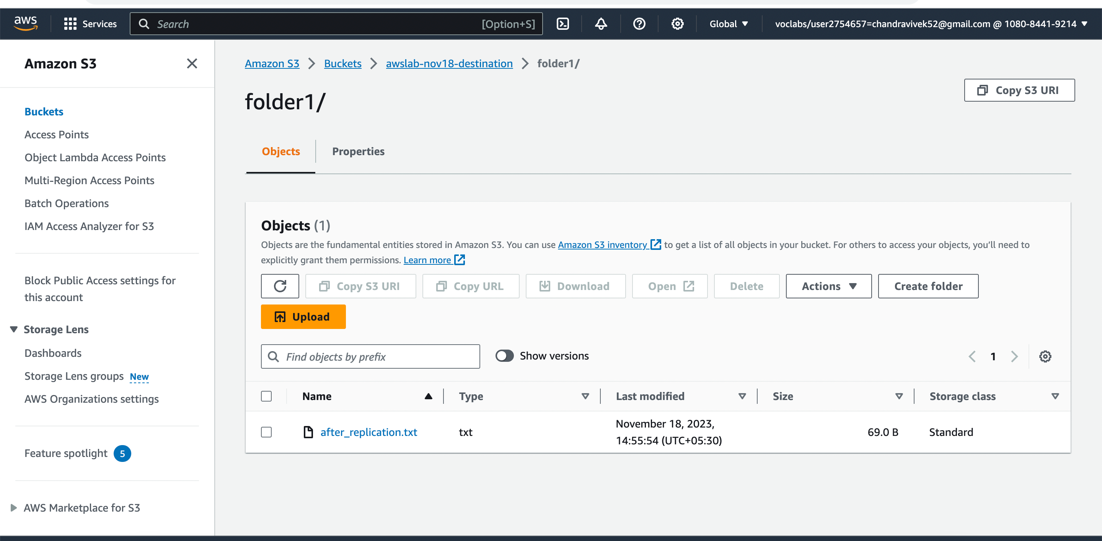

iv. After Replication – Phase II

Making some changes to the existing file ‘before_replication.txt’ and replicating it to the destination this time.

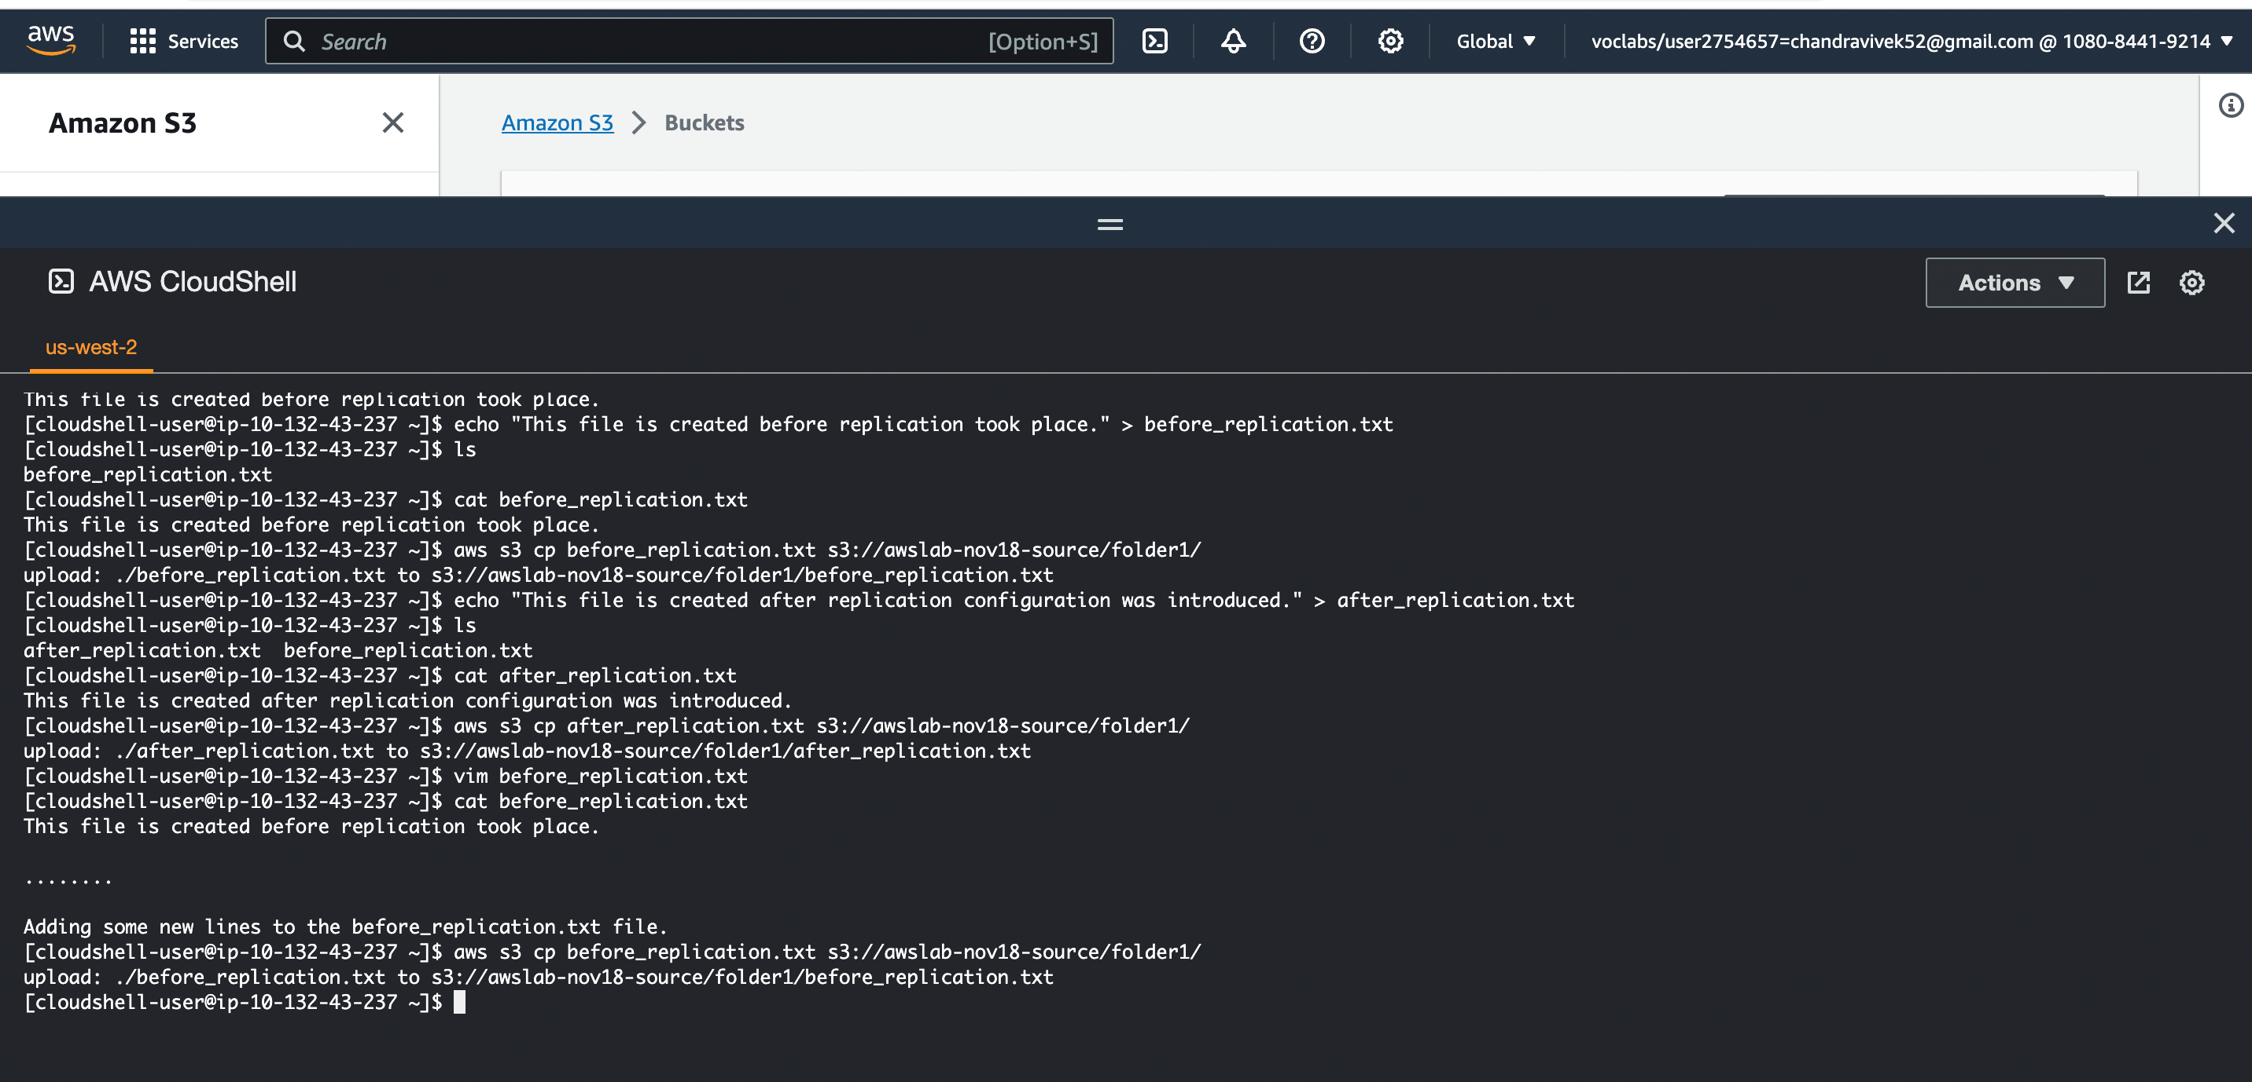

file ‘before_replication.txt’ is now replicated with modifications to the destination this time.

